TWO WAY COMMUNICATION

Prepare new app in angular with name parent

* ng new parent

Change the directory

* ng g c child

communication from parent to child

goto app.component..html and add the below code

<h1>Component Interaction</h1>

<app-child></app-child>

Start the app

* ng serve

app.component.html

<h1>Component Interaction</h1>

<h2>Parent Component</h2>

<!--Parent to child communication-->

<input type="text" (keyup)="0" #ptext>

<app-child [pdata]="ptext.value"></app-child>

Child.component.ts file

import { Component, OnInit } from '@angular/core';

@Component({

  selector: 'app-child',

  templateUrl: './child.component.html',

  styleUrls: ['./child.component.css'],

  inputs:['pdata'],

})

export class ChildComponent implements OnInit {

  pdata:string="";

  constructor() { }

  ngOnInit(): void {

  }

}

Child.component.html

<p>child works!</p>

<br>

<p>Value coming from Parent Component :<b> {{pdata}}</b></p>

Save it and check Parent to child component interaction is working

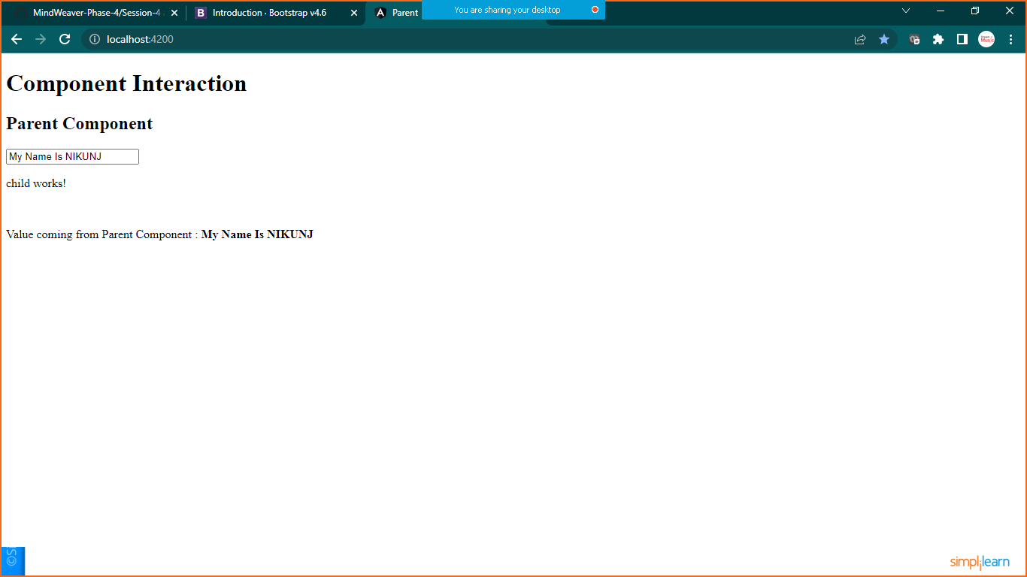

**CHILD TO PARENT COMMUNICATION**

Child.component.html

<p>child works!</p>

<br>

<p>Value coming from Parent Component :<b> {{pdata}}</b></p>

<hr>

<br>

<input type="text" #cdata (keyup)="onChange(cdata.value)">

Child .component.ts

import { Component, EventEmitter, OnInit } from '@angular/core';

@Component({

  selector: 'app-child',

  templateUrl: './child.component.html',

  styleUrls: ['./child.component.css'],

  inputs:['pdata'],

  outputs:['cevent'],

})

export class ChildComponent implements OnInit {

  pdata:string="";

  constructor() { }

  ngOnInit(): void {

  }

  cevent= new EventEmitter<String>();

  onChange(value:string){

    this.cevent.emit(value);

  }

}

App.component.html

<h1>Component Interaction</h1>

<h2>Parent Component</h2>

<!--Parent to child communication-->

<input type="text" (keyup)="0" #ptext>

<!--child to parent communication-->

<p> Value coming from child :<b>{{cdata}}</b></p>

<app-child [pdata]="ptext.value" (cevent)="cdata=$event"></app-child>

App.component.ts

import { Component } from '@angular/core';

@Component({

  selector: 'app-root',

  templateUrl: './app.component.html',

  styleUrls: ['./app.component.css']

})

export class AppComponent {

  title = 'parent';

  cdata:String="";

}

Save it and check the output

